SYSTEM REQUIRMENT SPECIFICATIONS
FOR
HOSTING SURVEY TOOL

INTRODUCTION TO PROJECT
Nowadays Survey and Analysis is an essential tool of business. A flexible survey tool that can be configured for any type of comments and can be published in a few minutes time is need of the hour. Here we propose a project that can create publish and conduct analysis on survey/review data effectively.
This project is a rating stars based on the score you assign. It can also calculate and output overall ratings you have assigned.

PURPOSE OF THE SYSTEM
- Websites are great. They're an easy way for one person to reach thousands of people with useful information. Here we are developing this application for Online Survey Tool. Online Survey Tool that can be configured for any type of comments and can be published in a few minutes time is need of the hour.
- In this application we are providing No of Product Type to users. But if user wants to get this Product He can give his own comments on product details. He can also view others comments assigned/given to the particular product details.

PROBLEMS IN EXISTING SYSTEM
The existing has following drawbacks.

- It is less user-friendly.
- It is having lots of manual work (Manual system does not mean that you are working with pen and paper, it also include working on spread sheets and other simple software's).
- The present system is very less secure.
- It is unable to generate different kinds of report.
- Multi-user environment is not provided.
- Accuracy not guaranteed.

PROPOSED SYSTEM
The development of this new system contains the following activities, which try to automate the entire process keeping in the view of database integration approach. The system makes the overall project management much easier and flexible. The user information files can be stored in centralized database which can be maintained by the system. This can give the good security for user information because data is not in client machine. Authentication is provided for this application only registered members can access. There is no risk of data management at any level while the project development is under process. Report generation is provided to generate different kind of reports. The system has an interface of grievance handling and status reporting to user.

FUNCTIONAL REQUIREMENTS
- Registration required authenticating the user
- Manage product information
- Post review to the corresponding product
- Display rating details
- Display product wise review information
- View product details
Non-Functional Requirements
Non-functional requirements describe user-visible aspects of the system that are not directly related to functionality of the system.
User Interface
A menu interface has been provided to the user to be user friendly.
Performance Constraints
Requests should be processed within no time.
Users should be authenticated for accessing the requested data
Error Handling and Extreme Conditions
In case of User Error, the System should display a meaningful error message to the user, such that the user can correct his Error.
The high level components in proposed system should handle exceptions that occur while connecting to various database servers, IO Exceptions etc.
Quality Issues
Quality issues mainly refers to reliable, available and robust system developing the proposed system the developer must be able to guarantee the reliability transactions so that they will be processed completely and accurately.
The ability of system to detect failures and recovery from those failures refers to the availability of system.
No. of Modules
- Administration
- Authorized User
- Product
- Reports
- Registration
- Authentication
Modules Description
- Administration:

Administration is the owner of the Online Survey Tool. He can have all the privileges to do anything in this system. Administrator can manage products (Camera, Mobiles, etc) in the system. He can view all types of products details (Sony camera, Canon camera, Samsung mobile, etc). He can also view comments under particular product.

- User:

He is a registered user to the Online Survey Tool. This user can view all products and product details. He can give his own comments on product details. He can also view others comments assigned/given to the particular product details.

- Product Details:

This module is used to maintain the various products available in the Online Survey Tool. Each product details available in the site should be under a product. This module will be enabled only to the admin type of users to manage product information.
- Reports:

- Generates product details comments report

- Registration:

The system has a process of registration. Every user need to submit their complete details including user name and password in the form of registration. Whenever a user registration completed then only a user can get log in into the system by using his user id and password.

- Authentication:

Authentication is nothing but providing security to the system. Here every must enter into the system through login page. The login page will restrict the UN authorized users. A user must provide his credential like user Id and password for log into the system. For that the system maintains data for all users. Whenever a user enters his user id and password, it checks in the database for user existence. If the user is exists he can be treated as a valid user. Otherwise the request will throw back.

No. of users
- Administration
- Authorized User
- Visitor

INPUT AND OUTPUT
The major inputs and outputs and major functions of the system are follows:
Inputs:
- Administrator enter his user id and password for login to authenticate in this system
- Administrator adds Product details to the system.
- Administrator views the comments of the visitors.
- Administrator can manage the products.
- User enter his user id and password for login to authenticate in this system
- Registered User need to submit their log in information for change their password.
- For searching Product need to choose the Product.
- For recover and change password settings Users need to submit their log information.
- For display Product details citizens need to choose Product type.

Outputs:
- Administrator can have his own home page. Citizens and Officer also can have their own home page after completion of the authentication process.
- Admin get all Users Information details.
- The registered user’s data can be stored in centralized database through the system user interface.
- Various types of information can be displayed to the users like Products, Product Types, comments etc. on the system user interface.
- After successful submission of log in information users can got their new password.
- Profile can be update by the users individually.

FEASIBILITY STUDY:
Preliminary investigation examine project feasibility, the likelihood the system will be useful to the organization. A Project Feasibility Study is an exercise that involves documenting each of the potential solutions to a particular business problem or opportunity. Feasibility Studies can be undertaken by any type of business, project or team and they are a critical part of the Project Life Cycle.
The purpose of a Feasibility Study is to identify the likelihood of one or more solutions meeting the stated business requirements. In other words, if you are unsure whether your solution will deliver the outcome you want, then a Project Feasibility Study will help gain that clarity. During the Feasibility Study, a variety of 'assessment' methods are undertaken. The outcome of the Feasibility Study is a confirmed solution for implementation.
The main objective of the feasibility study is to test the Technical, Operational and Economical feasibility for adding new modules and debugging old running system. All system is feasible if they are unlimited resources and infinite time. There are aspects in the feasibility study portion of the preliminary investigation:
- Technical Feasibility
- Economical Feasibility
- Operation Feasibility

Technical Feasibility:
In the feasibility study first step is that the organization or company has to decide that what technologies are suitable to develop by considering existing system.
Here in this application used the technologies like Visual Studio 2008 and Sql Server 2005. These are free software that would be downloaded from web.
Visual Studio 2008 –it is tool or technology.

Determining Economic Feasibility

For any system if the expected benefits equal or exceed the expected costs, the system can be judged to be economically feasible. In economic feasibility, cost benefit analysis is done in which expected costs and benefits are evaluated. Economic analysis is used for evaluating the effectiveness of the proposed system.
In economic feasibility, the most important is Cost-benefit analysis. As the name suggests, it is an analysis of the costs to be incurred in the system and benefits derivable out of the system. Click on the link below which will get you to the page that explains what cost benefit analysis is and how you can perform a cost benefit analysis.
Operational Feasibility
Not only must an application make economic and technical sense, it must also make operational sense.
Issues to consider when determining the operational feasibility of a project.
Operations Issues | Support Issues
- What tools are needed to support operations?  - What skills will operators need to be trained in?  - What processes need to be created and/or updated?  - What documentation does operations need? | - What documentation will users be given?  - What training will users be given?  - How will change requests be managed?
Very often you will need to improve the existing operations, maintenance, and support infrastructure to support the operation of the new application that you intend to develop. To determine what the impact will be you will need to understand both the current operations and support infrastructure of your organization and the operations and support characteristics of your new application.
To operate this application END-TO-END VMS. The user no need to require any technical knowledge that we are used to develop this project is Asp.net ,C#.net. That the application providing rich user interface by user can do the operation in flexible manner.

Process Architecture:
The Application is a program which is organized into three major disjunctive tiers. These tiers are

1. Presentation Tier (Frontend)
2. Logical Tier (Middleware)
3. Data Tier (Backend)

Each layer can be deployed in geographically separated computers in a network. We divide Logic Tier in to two sub tiers Business and Data Access Tiers, in order to increase scalability and transparency. The tiers can be deployed on physically separated machines. The characteristic of the tier communication is that the tiers will communicate only to their adjacent neighbors. For an example, The Presentation Tier will interact directly with the Business Tier and not directly with Data Access or Data Tiers.

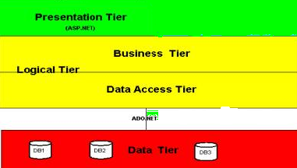

Architecture scenario

1. Presentation Tier

This Tier is responsible for communication with the users and it will use objects from Business Layer to response GUI raised events.

2.1 Logical Tier

This is the brain of the application. Some architects do not make any distinction between Business Tier and Data Access Tier. Their main argumentation is that additional tiers will screw down performance.We will have more advantages, if we separate Logical Tier in to Business Tier and Data Access Tier. Some of these advantages are

a. Increases code transparency
b. Supports changes in Data Layer. You can change or alter database without touching the Business Layer and this would be a very minimum touch up.

2.1 Business Tier

This sub tier contents classes to calculate aggregated values such like total revenue, cash flow and ebit and this tier doesnt know about any GUI controls and how to access databases. The classes of Data Access Tier will supply the needy information from the databases to this sub tier.

2.2 Data Access Tier

This tier acts as an interface to Data Tier. This tier knows, how to (from which database) retrieve and store information.

3. Data Tier

This Tier is responsible for retrieving, storing and updating from Information therefore this tier can be ideally represented through a commercial database. We consider stored procedures as a part of te Data Tier. Usage of stored procedures increases the performance and code transparency of an application

Software Development Life Cycle:
The Systems Development Life Cycle (SDLC), or Software Development Life Cycle in systems engineering, information systems and software engineering, is the process of creating or altering systems, and the models and methodologies use to develop these systems.
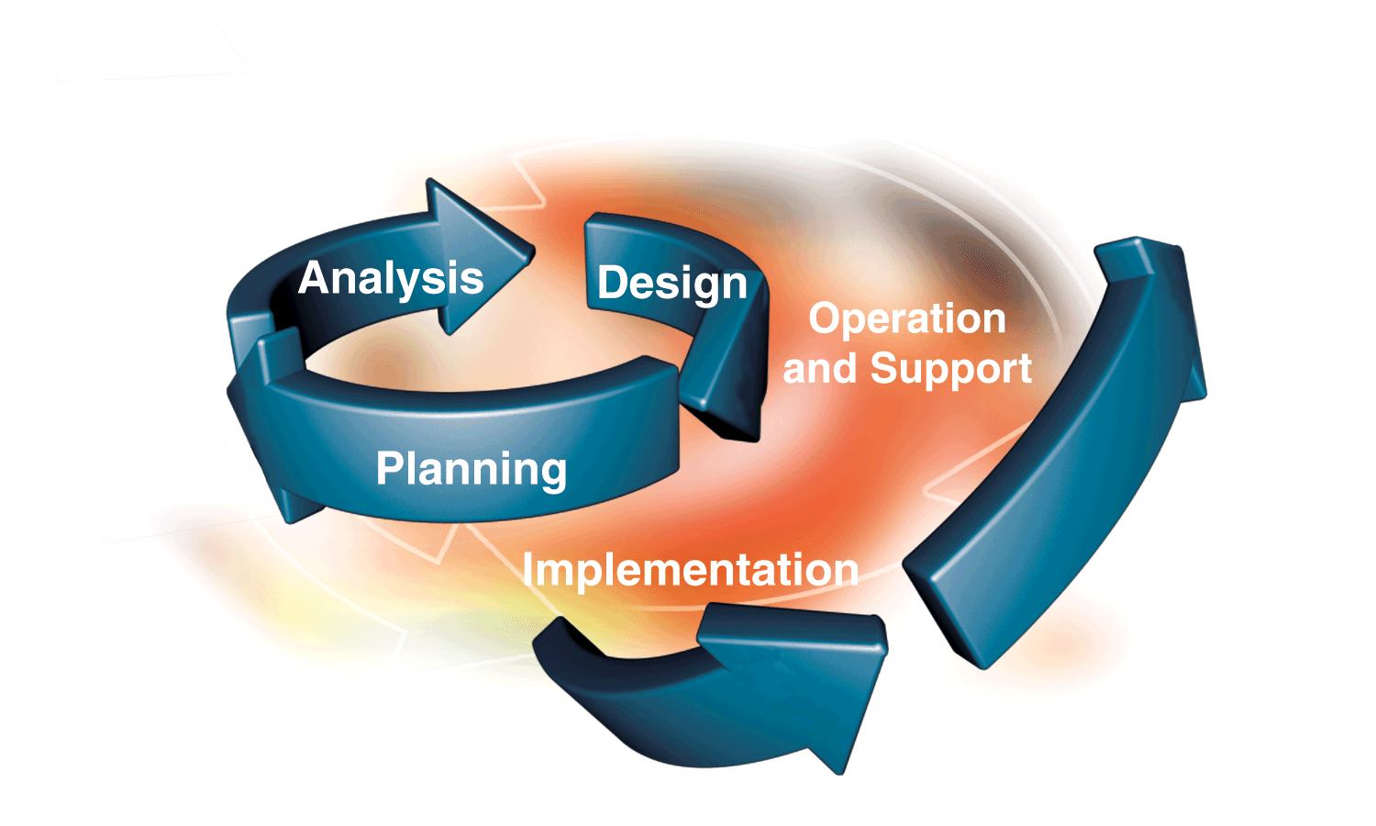
Requirement Analysis and Design
Analysis gathers the requirements for the system. This stage includes a detailed study of the business needs of the organization. Options for changing the business process may be considered. Design focuses on high level design like, what programs are needed and how are they going to interact, low-level design (how the individual programs are going to work), interface design (what are the interfaces going to look like) and data design (what data will be required). During these phases, the software's overall structure is defined. Analysis and Design are very crucial in the whole development cycle. Any glitch in the design phase could be very expensive to solve in the later stage of the software development. Much care is taken during this phase. The logical system of the product is developed in this phase.
Implementation
In this phase the designs are translated into code. Computer programs are written using a conventional programming language or an application generator. Programming tools like Compilers, Interpreters, Debuggers are used to generate the code. Different high level programming languages like C, C++, Pascal, Java, .Net are used for coding. With respect to the type of application, the right programming language is chosen.
Testing
In this phase the system is tested. Normally programs are written as a series of individual modules, these subject to separate and detailed test. The system is then tested as a whole. The separate modules are brought together and tested as a complete system. The system is tested to ensure that interfaces between modules work (integration testing), the system works on the intended platform and with the expected volume of data (volume testing) and that the system does what the user requires (acceptance/beta testing).
Maintenance
Inevitably the system will need maintenance. Software will definitely undergo change once it is delivered to the customer. There are many reasons for the change. Change could happen because of some unexpected input values into the system. In addition, the changes in the system could directly affect the software operations. The software should be developed to accommodate changes that could happen during the post implementation period.
SDLC METHDOLOGIES
This document play a vital role in the development of life cycle (SDLC) as it describes the complete requirement of the system. It means for use by developers and will be the basic during testing phase. Any changes made to the requirements in the future will have to go through formal change approval process.
SPIRAL MODEL was defined by Barry Boehm in his 1988 article, “A spiral Model of Software Development and Enhancement. This model was not the first model to discuss iterative development, but it was the first model to explain why the iteration models.
As originally envisioned, the iterations were typically 6 months to 2 years long. Each phase starts with a design goal and ends with a client reviewing the progress thus far. Analysis and engineering efforts are applied at each phase of the project, with an eye toward the end goal of the project.

The following diagram shows how a spiral model acts like:

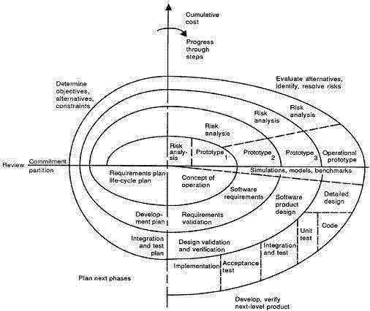

The steps for Spiral Model can be generalized as follows:
- The new system requirements are defined in as much details as possible. This usually involves interviewing a number of users representing all the external or internal users and other aspects of the existing system.
- A preliminary design is created for the new system.
- A first prototype of the new system is constructed from the preliminary design. This is usually a scaled-down system, and represents an approximation of the characteristics of the final product.
- A second prototype is evolved by a fourfold procedure:
- Evaluating the first prototype in terms of its strengths, weakness, and risks.
- Defining the requirements of the second prototype.
- Planning an designing the second prototype.
- Constructing and testing the second prototype.
- At the customer option, the entire project can be aborted if the risk is deemed too great. Risk factors might involved development cost overruns, operating-cost miscalculation, or any other factor that could, in the customer’s judgment, result in a less-than-satisfactory final product.
- The existing prototype is evaluated in the same manner as was the previous prototype, and if necessary, another prototype is developed from it according to the fourfold procedure outlined above.
- The preceding steps are iterated until the customer is satisfied that the refined prototype represents the final product desired.
- The final system is constructed, based on the refined prototype.
- The final system is thoroughly evaluated and tested. Routine maintenance is carried on a continuing basis to prevent large scale failures and to minimize down time.

CONTEXT LEVEL DIAGRAM
